PHASE 6 OF 8
Project Testing Phase
Testing, Validation & Security

Project | Platform | Team
Auto Ticket Classification using Flow Designer | ServiceNow (Flow Designer) | SAMRIN HASRAA S  SALMA FARHANA M  SAJITHA FATHIMA S K  FATHIMA M

1. Objective
Confirm that the solution meets the functional requirements, stores accurate data, and follows basic security and access-control practices.

2. Test Approach
Type | What is checked
Functional testing | Each keyword branch of the flow classifies the ticket correctly
Notification testing | An email is generated for the caller
Data validation | Fields are captured accurately and references resolve
Flow testing | The Flow Designer *Test* feature runs without errors
Security check | ACLs and role exist for the custom table

3. Test Cases
ID | Scenario | Input (Short Description) | Expected result | Status
TC-01 | Wi-Fi issue | WiFi not working in library | Network / Wi-Fi; email sent | Pass
TC-02 | Projector issue | Projector not turning on | Hardware / Projector; email sent | Pass
TC-03 | Email notification | Any ticket above | Email with subject *Your Request for the issue has been submitted* in System Logs → Emails | Pass
TC-04 | Flow test run | Existing record via Test button | Flow completes without errors | Pass
TC-05 | Password issue | Forgot password for student portal | Access / Forgot Password | To execute
TC-06 | Slow computer | Slow Computer in lab | Performance / Slow Computer | To execute
TC-07 | No keyword | Need a new chair | Category stays empty (agent review) | To execute
TC-08 | Manual category | Ticket created with Category already selected | Flow does not run (trigger: Category is empty) | To execute
TC-01 to TC-04 were executed and captured in the project recording. Run TC-05 to TC-08 the same way, then paste your screenshots under Section 4 and change the status to Pass or Fail.

4. Test Execution and Evidence

Test Scenario 1 – Wi-Fi ticket
- Open the *Incident Workflow* table and click New.
- Select a Caller.
- Enter Short Description: Wi-Fi not working in library, then Submit and reload the form.
- Category and Subcategory are filled automatically (Network / Wi-Fi) and an email is sent to the caller.
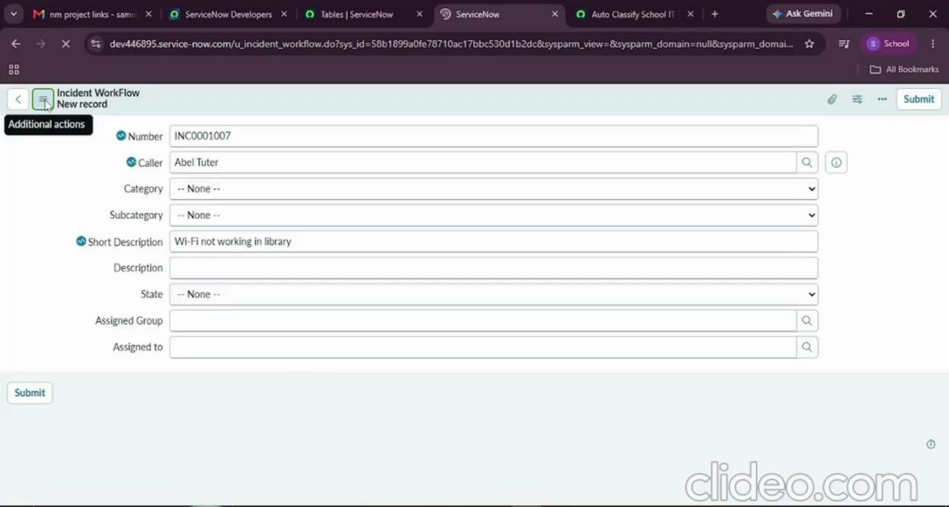
Figure 6.1 – Creating a test ticket with Caller and Short Description

Flow test run
Use the Test button in Flow Designer, choose an existing record and click Run Test. The flow finishes without errors.
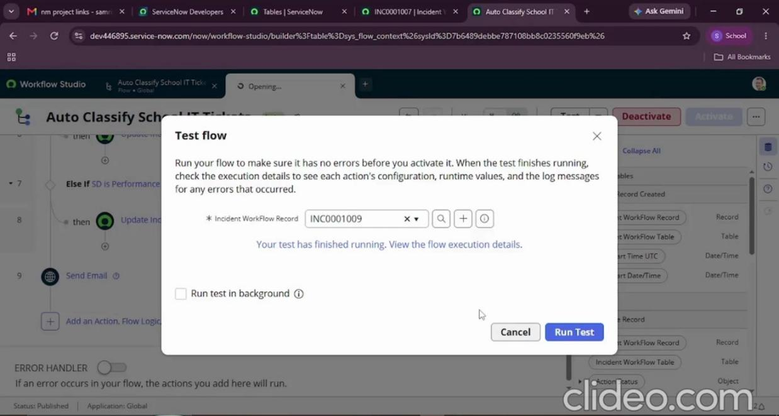
Figure 6.2 – Flow test completed

Test Scenario 2 – Projector ticket
Short Description Projector not turning on results in Category = Hardware and Subcategory = Projector.
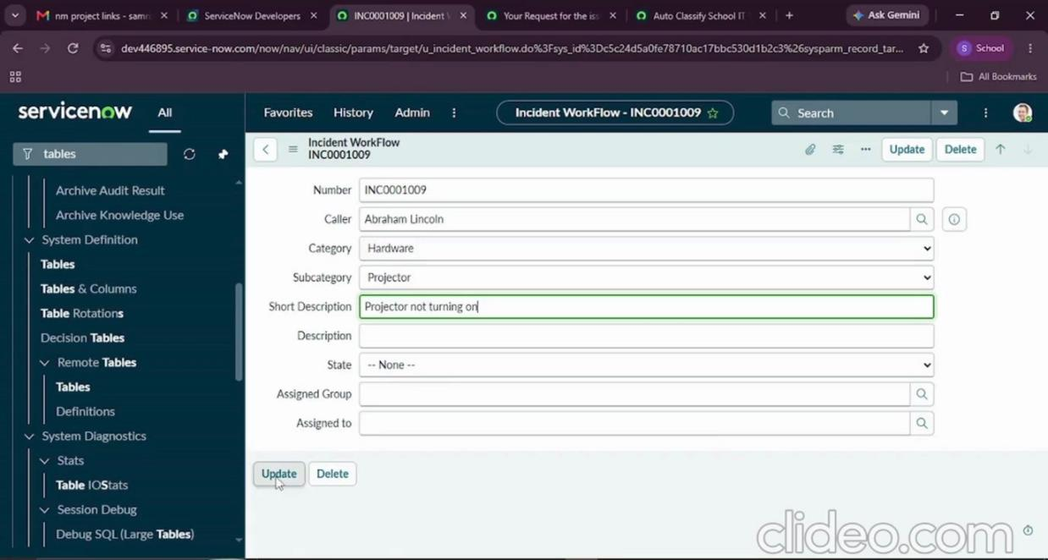
Figure 6.3 – Projector ticket after classification

Result list view
Both test tickets (INC0001007 and INC0001009) appear in the *Incident Workflow* list with automatically assigned Category values (Network and Hardware).
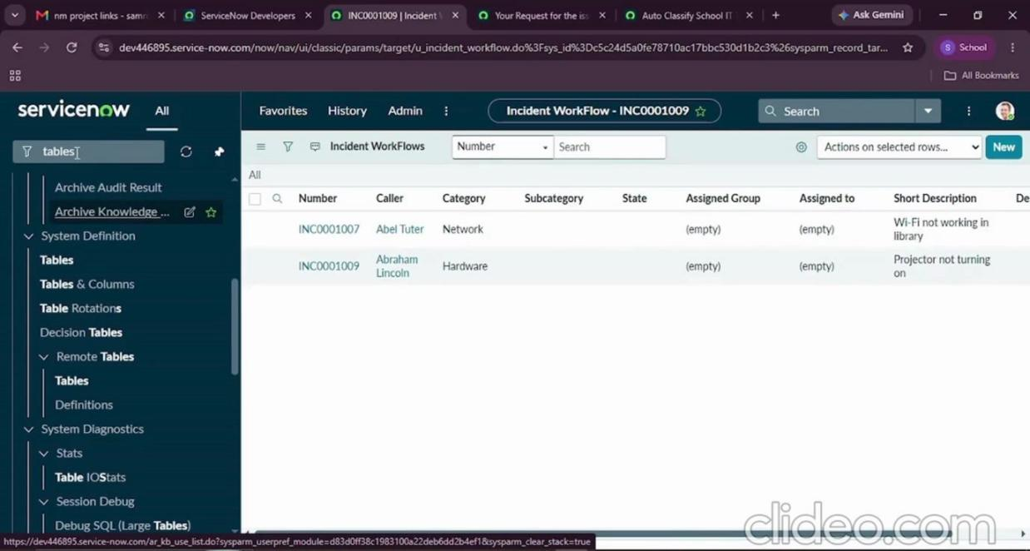
Figure 6.4 – List view of classified tickets

5. Email Notification Check
- Go to All → System Logs → Emails.
- Search using the subject *Your Request for the issue has been submitted*.
- Open the record and under *Related Links* click Preview Email to view the message.

6. Data Validation Checks
Check | Result
Mandatory fields captured correctly | Pass
Auto-number generated without duplication (INC0001007, INC0001009) | Pass
Category and Subcategory values stored accurately | Pass
Reference fields resolve to user and group tables | Pass
Subcategory list filtered by Category (dependent choice) | Pass

7. Security Validation
The table's Access Controls are listed on the table record (*Access Controls* related list): default ACLs for create, read, write and delete on u_incident_workflow, protected by the role u_incident_workflow_user.
Operation | ACL on u_incident_workflow | Active
Create | Yes | Yes
Read | Yes | Yes
Write | Yes | Yes
Delete | Yes | Yes

Only users holding the role (or admin) can work with ticket data, so unauthorised users cannot read or modify records.

8. Observations
- The flow only runs when Category is empty, so manually classified tickets are not overwritten.
- A ticket with no matching keyword remains unclassified and must be handled by an agent; new keywords can be added as extra *Else If* branches.

9. Conclusion
The main functional scenarios (Wi-Fi and Projector), the email notification and flow execution work as expected, data is stored accurately, and access controls protect the table.

